Ophüls, Max (1902-1957)
Thomas Patrick Pringle (McGill University)
Max Ophüls is an important critic and filmmaker of the post-war period, known for his opulent set design, kinetic long-takes, and proto-feminist melodramas, a source of inspiration for the French New Wave. Born into a family of wealthy Jewish textile-industrialists in Saarbrücken, Germany, the young stage director changed surnames from Oppenheimer to Ophüls to spare his relatives the shame of his pursuing a career in the arts. He directed five films in Germany before fleeing to Paris after the burning of the Reichstag in 1933. He subsequently escaped Europe in 1941 and joined the Jewish émigré directors in Hollywood. After several years of unemployment, Ophüls directed his best-known American features: The Exile (1948) and Letter from an Unknown Woman (1948). Upon returning to France, Ophüls interviewed with two young Cahiers du Cinéma journalists while shooting The Earrings of Madame De… (1953): Jacques Rivette and François Truffaut. Ophüls took a particular interest in Truffaut, asking him to assist him on Lola Montes (1955) and encouraging the young cineaste to try his hand at direction. Truffaut would later mount an academic defense of Ophüls work. Ophüls died from heart disease in 1957. His son, Marcel Ophüls, is a noted documentary filmmaker.
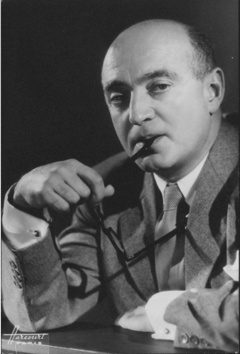
Image source BFI: http://explore.bfi.org.uk/4ce2b9f598c68
The ‘kinetic’ long-take in The Earrings of Madame De… : http://www.youtube.com/watch?v=9U_julmmUsE
Further Reading and References:

Baecque, Antoine , and Serge Toubiana. (1999) Truffaut: A Biography. New York: Knopf.
Bock, Hans-Michael, and Tim Bergfelder. (2009) The Concise Cinegraph: Encyclopaedia of German Cinema. New York: Berghahn Books.
Guérin, William K. (1998) Max Ophüls. Paris: Cahiers du Cinéma.
White, Susan M. The Cinema of Max Ophüls: Magisterial Vision and the Figure of Woman. (1995) New York: Columbia University Press.
Willemen, Paul. (1978) Ophüls. London: British Film Institute.

Thomas Patrick Pringle
McGill University

